1#:
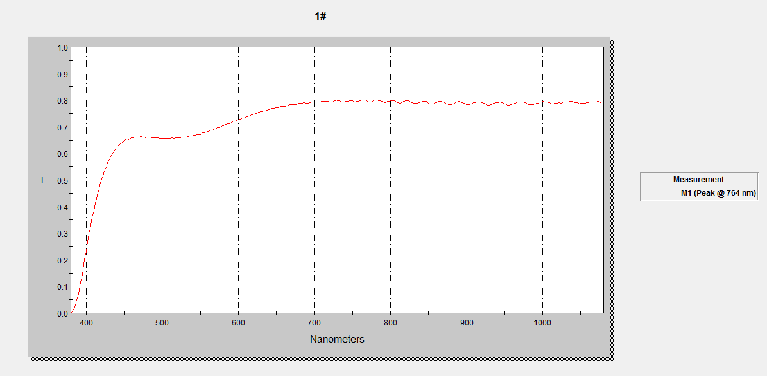

1#
nm | T
380 | 0.0%
382 | 0.6%
384 | 1.6%
386 | 3.0%
388 | 4.9%
390 | 7.3%
392 | 10.3%
394 | 13.3%
396 | 16.3%
398 | 20.0%
400 | 23.2%
402 | 26.6%
404 | 29.9%
406 | 32.9%
408 | 36.1%
410 | 38.5%
412 | 41.0%
414 | 43.2%
416 | 45.6%
418 | 48.0%
420 | 49.7%
422 | 51.4%
424 | 53.5%
426 | 54.6%
428 | 56.2%
430 | 57.4%
432 | 58.6%
434 | 59.7%
436 | 60.4%
438 | 61.5%
440 | 62.1%
442 | 63.0%
444 | 63.5%
446 | 63.9%
448 | 64.2%
450 | 65.0%
452 | 65.3%
454 | 65.5%
456 | 65.3%
458 | 65.6%
460 | 65.8%
462 | 65.9%
464 | 66.1%
466 | 66.1%
468 | 66.2%
470 | 66.2%
472 | 66.3%
474 | 66.2%
476 | 66.1%
478 | 65.9%
480 | 66.1%
482 | 66.1%
484 | 66.0%
486 | 65.9%
488 | 65.9%
490 | 65.8%
492 | 65.9%
494 | 65.8%
496 | 65.7%
498 | 65.6%
500 | 65.6%
502 | 65.7%
504 | 65.6%
506 | 65.6%
508 | 65.6%
510 | 65.7%
512 | 65.8%
514 | 65.6%
516 | 65.7%
518 | 65.9%
520 | 65.8%
522 | 65.8%
524 | 66.0%
526 | 66.0%
528 | 66.2%
530 | 66.1%
532 | 66.2%
534 | 66.5%
536 | 66.5%
538 | 66.5%
540 | 66.5%
542 | 66.8%
544 | 66.9%
546 | 67.1%
548 | 67.1%
550 | 67.2%
552 | 67.5%
554 | 67.8%
556 | 67.8%
558 | 67.9%
560 | 68.3%
562 | 68.6%
564 | 68.6%
566 | 68.7%
568 | 68.9%
570 | 69.3%
572 | 69.6%
574 | 69.7%
576 | 69.8%
578 | 70.1%
580 | 70.4%
582 | 70.7%
584 | 70.9%
586 | 71.1%
588 | 71.2%
590 | 71.5%
592 | 71.8%
594 | 72.1%
596 | 72.2%
598 | 72.4%
600 | 72.6%
602 | 72.8%
604 | 73.2%
606 | 73.4%
608 | 73.4%
610 | 73.7%
612 | 73.9%
614 | 74.1%
616 | 74.4%
618 | 74.5%
620 | 74.7%
622 | 74.9%
624 | 75.1%
626 | 75.4%
628 | 75.5%
630 | 75.7%
632 | 75.7%
634 | 75.9%
636 | 76.1%
638 | 76.3%
640 | 76.5%
642 | 76.6%
644 | 76.8%
646 | 76.9%
648 | 77.0%
650 | 77.1%
652 | 77.3%
654 | 77.5%
656 | 77.6%
658 | 77.7%
660 | 77.7%
662 | 77.8%
664 | 77.9%
666 | 78.1%
668 | 78.3%
670 | 78.3%
672 | 78.4%
674 | 78.4%
676 | 78.3%
678 | 78.5%
680 | 78.7%
682 | 78.9%
684 | 78.9%
686 | 79.0%
688 | 78.9%
690 | 78.8%
692 | 78.9%
694 | 79.1%
696 | 79.3%
698 | 79.4%
700 | 79.4%
702 | 79.3%
704 | 79.2%
706 | 79.3%
708 | 79.4%
710 | 79.5%
712 | 79.7%
714 | 79.7%
716 | 79.7%
718 | 79.6%
720 | 79.4%
722 | 79.3%
724 | 79.4%
726 | 79.7%
728 | 79.9%
730 | 79.9%
732 | 79.8%
734 | 79.6%
736 | 79.3%
738 | 79.3%
740 | 79.2%
742 | 79.5%
744 | 79.7%
746 | 79.9%
748 | 79.7%
750 | 79.7%
752 | 79.4%
754 | 79.3%
756 | 79.5%
758 | 79.6%
760 | 79.9%
762 | 80.1%
764 | 80.1%
766 | 80.0%
768 | 79.7%
770 | 79.5%
772 | 79.3%
774 | 79.4%
776 | 79.5%
778 | 79.7%
780 | 80.0%
782 | 80.1%
784 | 79.9%
786 | 79.8%
788 | 79.5%
790 | 79.2%
792 | 79.2%
794 | 79.2%
796 | 79.5%
798 | 79.6%
800 | 79.8%
802 | 79.9%
804 | 79.8%
806 | 79.5%
808 | 79.3%
810 | 79.1%
812 | 79.0%
814 | 79.0%
816 | 79.3%
818 | 79.6%
820 | 79.7%
822 | 79.8%
824 | 79.7%
826 | 79.4%
828 | 79.1%
830 | 78.9%
832 | 78.8%
834 | 78.7%
836 | 78.9%
838 | 79.2%
840 | 79.4%
842 | 79.6%
844 | 79.6%
846 | 79.5%
848 | 79.2%
850 | 78.9%
852 | 78.6%
854 | 78.5%
856 | 78.6%
858 | 78.8%
860 | 79.0%
862 | 79.2%
864 | 79.5%
866 | 79.5%
868 | 79.4%
870 | 79.2%
872 | 78.9%
874 | 78.6%
876 | 78.5%
878 | 78.3%
880 | 78.4%
882 | 78.6%
884 | 78.9%
886 | 79.1%
888 | 79.3%
890 | 79.5%
892 | 79.3%
894 | 79.1%
896 | 78.9%
898 | 78.6%
900 | 78.4%
902 | 78.3%
904 | 78.3%
906 | 78.5%
908 | 78.7%
910 | 79.0%
912 | 79.2%
914 | 79.3%
916 | 79.3%
918 | 79.3%
920 | 79.0%
922 | 78.7%
924 | 78.5%
926 | 78.3%
928 | 78.2%
930 | 78.2%
932 | 78.3%
934 | 78.6%
936 | 78.8%
938 | 79.0%
940 | 79.2%
942 | 79.2%
944 | 79.2%
946 | 79.1%
948 | 78.8%
950 | 78.6%
952 | 78.3%
954 | 78.2%
956 | 78.2%
958 | 78.3%
960 | 78.5%
962 | 78.7%
964 | 78.9%
966 | 79.1%
968 | 79.3%
970 | 79.3%
972 | 79.4%
974 | 79.3%
976 | 79.1%
978 | 78.8%
980 | 78.5%
982 | 78.5%
984 | 78.4%
986 | 78.3%
988 | 78.4%
990 | 78.7%
992 | 78.8%
994 | 78.9%
996 | 79.3%
998 | 79.4%

1000 | 79.2%
1005 | 79.2%
1010 | 79.3%
1015 | 79.3%
1020 | 79.3%
1025 | 79.4%
1030 | 79.4%
1035 | 79.4%
1040 | 79.6%
1045 | 79.6%
1050 | 79.6%
1055 | 79.6%
1060 | 79.7%
1065 | 79.7%
1070 | 79.8%
1075 | 79.9%
1080 | 79.9%
1085 | 79.9%
1090 | 79.9%
1095 | 79.9%
1100 | 80.0%
1105 | 80.0%
1110 | 80.1%
1115 | 80.2%
1120 | 80.2%
1125 | 80.2%
1130 | 80.2%
1135 | 80.2%
1140 | 80.3%
1145 | 80.3%
1150 | 80.3%
1155 | 80.4%
1160 | 80.4%
1165 | 80.4%
1170 | 80.3%
1175 | 80.4%
1180 | 80.4%
1185 | 80.5%
1190 | 80.5%
1195 | 80.5%
1200 | 80.6%
1205 | 80.6%
1210 | 80.6%
1215 | 80.7%
1220 | 80.7%
1225 | 80.8%
1230 | 80.7%
1235 | 80.7%
1240 | 80.7%
1245 | 80.7%
1250 | 80.8%
1255 | 80.8%
1260 | 80.9%
1265 | 80.9%
1270 | 81.0%
1275 | 81.0%
1280 | 81.0%
1285 | 80.9%
1290 | 80.9%
1295 | 80.9%
1300 | 80.9%
1305 | 81.0%
1310 | 81.0%
1315 | 81.1%
1320 | 81.1%
1325 | 81.1%
1330 | 81.0%
1335 | 80.8%
1340 | 80.7%
1345 | 80.6%
1350 | 80.5%
1355 | 80.3%
1360 | 80.1%
1365 | 79.9%
1370 | 79.5%
1375 | 79.1%
1380 | 78.7%
1385 | 78.4%
1390 | 78.2%
1395 | 78.1%
1400 | 78.1%
1405 | 78.2%
1410 | 78.5%
1415 | 78.7%
1420 | 78.9%
1425 | 79.1%
1430 | 79.2%
1435 | 79.4%
1440 | 79.4%
1445 | 79.4%
1450 | 79.4%
1455 | 79.3%
1460 | 79.2%
1465 | 79.2%
1470 | 79.1%
1475 | 79.2%
1480 | 79.3%
1485 | 79.5%
1490 | 79.8%
1495 | 80.0%
1500 | 80.2%
1505 | 80.3%
1510 | 80.3%
1515 | 80.3%
1520 | 80.2%
1525 | 80.1%
1530 | 79.9%
1535 | 79.8%
1540 | 79.7%
1545 | 79.6%
1550 | 79.8%
1555 | 79.8%
1560 | 80.0%
1565 | 80.2%
1570 | 80.4%
1575 | 80.5%
1580 | 80.6%
1585 | 80.6%
1590 | 80.5%
1595 | 80.4%
1600 | 80.2%
1605 | 79.9%
1610 | 79.7%
1615 | 79.5%
1620 | 79.3%
1625 | 79.3%
1630 | 79.3%
1635 | 79.4%
1640 | 79.5%
1645 | 79.6%
1650 | 79.7%
1655 | 79.7%
1660 | 79.8%
1665 | 79.6%
1670 | 79.4%
1675 | 79.1%
1680 | 78.8%
1685 | 78.4%
1690 | 78.0%
1695 | 77.6%
1700 | 77.3%
1705 | 77.1%
1710 | 76.9%
1715 | 76.7%
1720 | 76.7%
1725 | 76.7%
1730 | 76.7%
1735 | 76.8%
1740 | 76.9%
1745 | 77.0%
1750 | 77.1%
1755 | 77.2%
1760 | 77.2%
1765 | 77.2%
1770 | 77.1%
1775 | 77.0%
1780 | 76.7%
1785 | 76.5%
1790 | 76.3%
1795 | 76.0%
1800 | 75.9%

2#:
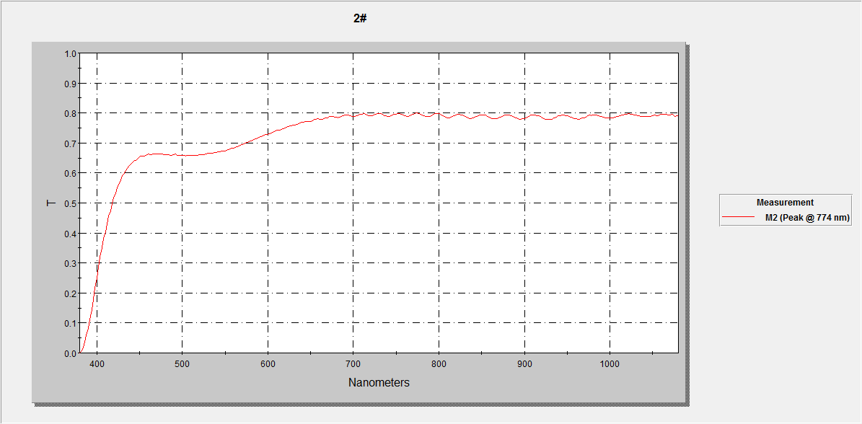

2#
nm | T
380 | 0.0%
382 | 0.5%
384 | 1.8%
386 | 3.5%
388 | 6.0%
390 | 8.2%
392 | 11.1%
394 | 14.5%
396 | 17.9%
398 | 21.6%
400 | 25.0%
402 | 28.6%
404 | 32.0%
406 | 35.0%
408 | 38.2%
410 | 40.5%
412 | 43.0%
414 | 45.6%
416 | 47.5%
418 | 49.9%
420 | 51.7%
422 | 53.4%
424 | 55.1%
426 | 56.4%
428 | 57.7%
430 | 59.0%
432 | 59.9%
434 | 60.8%
436 | 61.6%
438 | 62.4%
440 | 63.0%
442 | 63.7%
444 | 64.2%
446 | 64.3%
448 | 64.8%
450 | 65.3%
452 | 65.5%
454 | 65.7%
456 | 65.7%
458 | 66.0%
460 | 66.2%
462 | 66.2%
464 | 66.2%
466 | 66.3%
468 | 66.4%
470 | 66.3%
472 | 66.3%
474 | 66.4%
476 | 66.3%
478 | 66.0%
480 | 66.0%
482 | 66.1%
484 | 66.2%
486 | 66.0%
488 | 65.8%
490 | 66.1%
492 | 66.3%
494 | 65.9%
496 | 65.8%
498 | 65.8%
500 | 65.8%
502 | 65.9%
504 | 65.7%
506 | 65.8%
508 | 65.8%
510 | 66.0%
512 | 65.9%
514 | 65.9%
516 | 65.8%
518 | 65.9%
520 | 66.1%
522 | 66.1%
524 | 66.1%
526 | 66.0%
528 | 66.2%
530 | 66.5%
532 | 66.6%
534 | 66.6%
536 | 66.6%
538 | 66.8%
540 | 66.8%
542 | 67.1%
544 | 67.1%
546 | 67.3%
548 | 67.4%
550 | 67.4%
552 | 67.6%
554 | 67.9%
556 | 68.1%
558 | 68.2%
560 | 68.4%
562 | 68.5%
564 | 68.8%
566 | 69.1%
568 | 69.3%
570 | 69.4%
572 | 69.7%
574 | 69.9%
576 | 70.1%
578 | 70.6%
580 | 70.8%
582 | 70.9%
584 | 71.2%
586 | 71.4%
588 | 71.5%
590 | 71.8%
592 | 72.1%
594 | 72.4%
596 | 72.7%
598 | 72.8%
600 | 72.9%
602 | 73.1%
604 | 73.4%
606 | 73.6%
608 | 73.9%
610 | 74.2%
612 | 74.3%
614 | 74.4%
616 | 74.6%
618 | 74.7%
620 | 75.1%
622 | 75.4%
624 | 75.6%
626 | 75.7%
628 | 75.8%
630 | 75.9%
632 | 75.9%
634 | 76.2%
636 | 76.4%
638 | 76.7%
640 | 76.9%
642 | 77.0%
644 | 77.1%
646 | 77.1%
648 | 77.2%
650 | 77.2%
652 | 77.5%
654 | 77.8%
656 | 78.0%
658 | 78.1%
660 | 78.0%
662 | 77.8%
664 | 77.9%
666 | 78.0%
668 | 78.3%
670 | 78.5%
672 | 78.8%
674 | 78.9%
676 | 78.8%
678 | 78.6%
680 | 78.5%
682 | 78.4%
684 | 78.6%
686 | 78.9%
688 | 79.1%
690 | 79.3%
692 | 79.4%
694 | 79.3%
696 | 79.1%
698 | 78.8%
700 | 78.8%
702 | 78.9%
704 | 79.1%
706 | 79.4%
708 | 79.6%
710 | 79.7%
712 | 79.8%
714 | 79.5%
716 | 79.3%
718 | 79.0%
720 | 79.0%
722 | 79.0%
724 | 79.3%
726 | 79.6%
728 | 79.8%
730 | 79.9%
732 | 79.9%
734 | 79.5%
736 | 79.1%
738 | 79.0%
740 | 78.8%
742 | 78.9%
744 | 79.0%
746 | 79.4%
748 | 79.5%
750 | 79.6%
752 | 79.7%
754 | 79.7%
756 | 79.6%
758 | 79.2%
760 | 79.1%
762 | 79.0%
764 | 79.0%
766 | 79.1%
768 | 79.3%
770 | 79.7%
772 | 79.8%
774 | 79.9%
776 | 79.9%
778 | 79.6%
780 | 79.4%
782 | 79.1%
784 | 78.8%
786 | 78.8%
788 | 78.8%
790 | 78.9%
792 | 79.2%
794 | 79.5%
796 | 79.8%
798 | 79.8%
800 | 79.7%
802 | 79.5%
804 | 79.1%
806 | 78.9%
808 | 78.6%
810 | 78.4%
812 | 78.4%
814 | 78.6%
816 | 78.9%
818 | 79.2%
820 | 79.4%
822 | 79.6%
824 | 79.6%
826 | 79.4%
828 | 79.2%
830 | 79.0%
832 | 78.6%
834 | 78.4%
836 | 78.2%
838 | 78.2%
840 | 78.3%
842 | 78.6%
844 | 78.9%
846 | 79.1%
848 | 79.4%
850 | 79.4%
852 | 79.4%
854 | 79.2%
856 | 79.1%
858 | 78.7%
860 | 78.4%
862 | 78.2%
864 | 78.1%
866 | 78.0%
868 | 78.1%
870 | 78.3%
872 | 78.6%
874 | 78.9%
876 | 79.1%
878 | 79.3%
880 | 79.4%
882 | 79.2%
884 | 79.1%
886 | 78.8%
888 | 78.6%
890 | 78.3%
892 | 78.1%
894 | 78.0%
896 | 77.9%
898 | 78.1%
900 | 78.2%
902 | 78.5%
904 | 78.7%
906 | 79.0%
908 | 79.3%
910 | 79.4%
912 | 79.3%
914 | 79.2%
916 | 79.0%
918 | 78.8%
920 | 78.5%
922 | 78.2%
924 | 78.0%
926 | 77.8%
928 | 77.8%
930 | 77.9%
932 | 78.0%
934 | 78.3%
936 | 78.5%
938 | 78.8%
940 | 79.1%
942 | 79.1%
944 | 79.2%
946 | 79.3%
948 | 79.2%
950 | 79.1%
952 | 78.8%
954 | 78.6%
956 | 78.4%
958 | 78.2%
960 | 78.1%
962 | 78.0%
964 | 78.0%
966 | 78.2%
968 | 78.4%
970 | 78.5%
972 | 78.7%
974 | 79.0%
976 | 79.3%
978 | 79.2%
980 | 79.3%
982 | 79.4%
984 | 79.3%
986 | 79.2%
988 | 78.9%
990 | 78.8%
992 | 78.6%
994 | 78.5%
996 | 78.4%
998 | 78.4%

1000 | 78.1%
1005 | 78.1%
1010 | 78.2%
1015 | 78.2%
1020 | 78.2%
1025 | 78.3%
1030 | 78.4%
1035 | 78.4%
1040 | 78.4%
1045 | 78.5%
1050 | 78.6%
1055 | 78.6%
1060 | 78.7%
1065 | 78.7%
1070 | 78.7%
1075 | 78.7%
1080 | 78.8%
1085 | 78.8%
1090 | 78.9%
1095 | 79.0%
1100 | 79.1%
1105 | 79.1%
1110 | 79.1%
1115 | 79.1%
1120 | 79.1%
1125 | 79.1%
1130 | 79.1%
1135 | 79.2%
1140 | 79.3%
1145 | 79.4%
1150 | 79.4%
1155 | 79.5%
1160 | 79.5%
1165 | 79.4%
1170 | 79.3%
1175 | 79.3%
1180 | 79.3%
1185 | 79.2%
1190 | 79.4%
1195 | 79.5%
1200 | 79.7%
1205 | 79.8%
1210 | 79.9%
1215 | 79.9%
1220 | 79.8%
1225 | 79.7%
1230 | 79.6%
1235 | 79.5%
1240 | 79.4%
1245 | 79.5%
1250 | 79.6%
1255 | 79.8%
1260 | 79.9%
1265 | 80.1%
1270 | 80.2%
1275 | 80.2%
1280 | 80.1%
1285 | 80.0%
1290 | 79.8%
1295 | 79.7%
1300 | 79.6%
1305 | 79.5%
1310 | 79.6%
1315 | 79.7%
1320 | 79.8%
1325 | 80.0%
1330 | 80.1%
1335 | 80.2%
1340 | 80.2%
1345 | 80.0%
1350 | 79.8%
1355 | 79.4%
1360 | 78.9%
1365 | 78.2%
1370 | 77.6%
1375 | 77.0%
1380 | 76.6%
1385 | 76.4%
1390 | 76.4%
1395 | 76.7%
1400 | 77.1%
1405 | 77.5%
1410 | 77.9%
1415 | 78.0%
1420 | 78.1%
1425 | 78.0%
1430 | 77.9%
1435 | 77.7%
1440 | 77.5%
1445 | 77.5%
1450 | 77.4%
1455 | 77.5%
1460 | 77.7%
1465 | 77.9%
1470 | 78.2%
1475 | 78.4%
1480 | 78.7%
1485 | 79.0%
1490 | 79.1%
1495 | 79.2%
1500 | 79.2%
1505 | 79.2%
1510 | 79.0%
1515 | 78.8%
1520 | 78.6%
1525 | 78.4%
1530 | 78.3%
1535 | 78.2%
1540 | 78.2%
1545 | 78.2%
1550 | 78.4%
1555 | 78.6%
1560 | 78.8%
1565 | 79.0%
1570 | 79.2%
1575 | 79.4%
1580 | 79.6%
1585 | 79.6%
1590 | 79.6%
1595 | 79.5%
1600 | 79.3%
1605 | 79.1%
1610 | 78.8%
1615 | 78.6%
1620 | 78.3%
1625 | 78.0%
1630 | 77.9%
1635 | 77.7%
1640 | 77.6%
1645 | 77.6%
1650 | 77.7%
1655 | 77.7%
1660 | 77.9%
1665 | 77.9%
1670 | 78.0%
1675 | 78.0%
1680 | 77.9%
1685 | 77.8%
1690 | 77.7%
1695 | 77.5%
1700 | 77.2%
1705 | 77.0%
1710 | 76.6%
1715 | 76.3%
1720 | 75.9%
1725 | 75.6%
1730 | 75.3%
1735 | 75.0%
1740 | 74.8%
1745 | 74.6%
1750 | 74.6%
1755 | 74.6%
1760 | 74.7%
1765 | 74.9%
1770 | 75.1%
1775 | 75.3%
1780 | 75.4%
1785 | 75.6%
1790 | 75.8%
1795 | 75.9%
1800 | 75.9%

